Origami Case Study

Brief overview of analysis

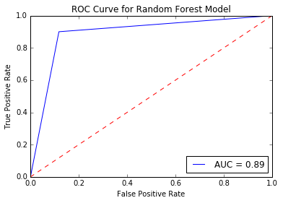In partnering with StrategyWise, Origami presented us with some of the issues they have been struggling with lately. They reached out to us in an effort to better understand how they can gain actionable insights in their efforts to place and retain the best workers, as well as increase efficiency in other areas of operations. Below is a summary of what has been learned so far.

# Areas of Discovery

### **Likelihood of a Worker being Successful (Python)**

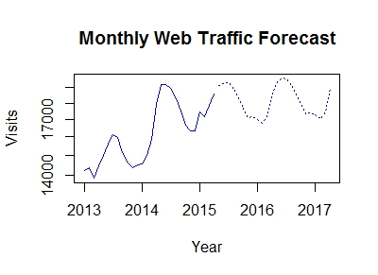A decision tree (random forest) model was implemented, able to predict the future success (as measured by 6-month retention) of an incoming worker with up to **80%** accuracy using the data provided by Origami. Between multiple runs, the AUC hovered between **.85** and **.90**, and this information can be used to better pre-screen candidates to better serve clients and decrease time spent recruiting.

### **Web Traffic Analysis (R)**

In implementing a time-series model on the historical data provided by Origami, future web traffic was modeled over a 24-month future. With the volatility of the original data, it would be naive to assume it can be predicted much farther out with accuracy, but the model captures the **general upward trend** and **seasonality** well enough to get a general idea within a 12-month window.

### **Modeling Ideal Job Type for Recruits (Python)**

The same model design was used as before in measuring the overall success of a worker, but in this *case two separate models* were created for both jobs types individually. A candidate can be run through both models and observe the likelihood of being successful in each one. Prediction accuracy was around **78%**.

### **Client Demographics (R)**

### Schedule Conflict Resolution

* + Britton is working on this. . .

### **Membership Level Prioritization**

While the marketing costs for Premium Memberships ($5) are slightly higher than Discount ($3), the revenue generated by Premium fars outweights that cost (+$20 for Premium over Discount). Therefore you should exhaust all of the Premium demand before focusing on Discount.

|  |  |  |
| --- | --- | --- |
| Assumption | Solution | Revenues |
| Demand stays static each month at Premium – 82, Discount – 150 | Sell 82 Premium / Month  Sell 118 Discount / Month | [82 * (25 – 5)] + 118 * (5 – 3) = $1876 |

### **Company Feedback Sentiment Analysis (Python)**

Using a sentiment analysis model *(credit to Javier Alba [https://github.com/fjavieralba])* I was able to extract and concatenate the feedback from the “Comments from the employer” column and feed it into model where it compared the words and sentence structure to arrive at a final score of **-3.0**.